WellPlanTM Report

Нефть Шельф
Well Name: IH-1
Wellbore:
Design:
Case: IH-1

Date: April 7, 2026 at 6:31 PM

Created By: Zaur Mollaev

General Information
  - General Case Information
Company | Нефть Шельф
Project | Нагнетательная скважина | Site | МЛСП
Well | IH-1 | Wellbore
Design |  | Case | IH-1
Hole MD | 2450,00 m | Hole TVD | 2209,54 m
Air Gap | 35,00 m | Water Depth | 50,00 m
Reference Point | Datum #1 @ m | Well Type | Platform
  - Active Fluid

Fluid Data
Fluid | Mud #1 | Type | Mud
Mud Base Type | Brine | Base Fluid | Brine
Rheology Model | Newtonian | Foamed

Compressibility Data
Oil (Vol)/Water (Vol) | 80,00 %/20,00 % | Reference Temperature | 21,111
Salt Content (wt) | 10,00 | Average Solid Gravity | 2,000

Rheology Data
Temperature  (°C) | Pressure  (kPa) | Base Density  (kg/m³) | Ref Fluid Properties | PV (Mulnf)  (mPa*s) | Fann Data
 |  |  |  |  | Speed  (rpm) | Dial  (°)
21,111 | 101,35 | 812 | Yes | 24
  - Hole Section
Section  Type | Section Depth  (m) | Section Length  (m) | Shoe Depth  (m) | ID  (mm) | Drift  (mm) | Eff. Hole Diameter  (mm) | Coefficient  of  Friction | Linear Capacity  (L/m) | Volume  Excess  (%)
Casing | 2450 | 2450 | 2450 | 220,5 | 219,08 | 311,15 | 0,23 | 38,19
  - String Details
Type | Length  (m) | Depth  (m) | Body |  | Stabilizer / Tool Joint |  |  |  | Weight | Material | Grade | Class
 |  |  | OD  (mm) | ID  (mm) | Avg Joint Length  (m) | Length  (m) | OD  (mm) | ID  (mm)
Tubing | 2448 | 2448 | 139,7 | 124,26 |  |  |  |  | 25,3 | CS_API 5CT | L-80
Packer | 2 | 2450 | 214 | 100,5 | 2 |  |  |  | 50 | CS_API 5CT | 4145H MOD

Grade in Use
Grade | Minimum Yield Stress (kPa)
4145H MOD | 758 423
L-80 | 551 581
  - Wellpath - Calculation Method: Minimum Curvature
MD  (m) | INC  (°) | AZ  (°) | TVD  (m) | DLS  (°/30m) | AbsTort  (°/30m) | RelTort  (°/30m) | VSect  (m) | NS  (m) | EW  (m) | Build  (°/30m) | Walk  (°/30m)
0,00 | 0,00 | 0,00 | 0,00 | 0,000 | 0,000 | 0,000 | 0,00 | 0,00 | 0,00 | 0,000 | 0,000
10,00 | 0,10 | 251,24 | 10,00 | 0,300 | 0,300 | 0,000 | 0,00 | 0,00 | -0,01 | 0,300 | 0,000
20,00 | 0,11 | 292,40 | 20,00 | 0,223 | 0,262 | 0,000 | 0,00 | 0,00 | -0,03 | 0,030 | 123,480
30,00 | 0,10 | 321,37 | 30,00 | 0,160 | 0,228 | 0,000 | 0,01 | 0,01 | -0,04 | -0,030 | 86,910
40,00 | 0,09 | 350,40 | 40,00 | 0,146 | 0,207 | 0,000 | 0,02 | 0,02 | -0,05 | -0,030 | 87,090
50,00 | 0,09 | 5,32 | 50,00 | 0,070 | 0,180 | 0,000 | 0,04 | 0,04 | -0,05 | 0,000 | 44,760
60,00 | 0,10 | 20,77 | 60,00 | 0,082 | 0,164 | 0,000 | 0,05 | 0,05 | -0,04 | 0,030 | 46,350
70,00 | 0,14 | 21,02 | 70,00 | 0,120 | 0,157 | 0,000 | 0,07 | 0,07 | -0,04 | 0,120 | 0,750
80,00 | 0,26 | 345,94 | 80,00 | 0,499 | 0,200 | 0,000 | 0,11 | 0,11 | -0,04 | 0,360 | -105,240
90,00 | 0,30 | 345,77 | 90,00 | 0,120 | 0,191 | 0,000 | 0,16 | 0,16 | -0,05 | 0,120 | -0,510
100,00 | 0,39 | 348,71 | 100,00 | 0,275 | 0,200 | 0,000 | 0,21 | 0,21 | -0,06 | 0,270 | 8,820
110,00 | 0,59 | 334,04 | 110,00 | 0,704 | 0,245 | 0,000 | 0,29 | 0,29 | -0,09 | 0,600 | -44,010
120,00 | 0,65 | 345,68 | 120,00 | 0,418 | 0,260 | 0,000 | 0,39 | 0,39 | -0,13 | 0,180 | 34,920
130,00 | 0,78 | 355,17 | 130,00 | 0,526 | 0,280 | 0,000 | 0,52 | 0,52 | -0,15 | 0,390 | 28,470
140,00 | 0,85 | 10,36 | 140,00 | 0,679 | 0,309 | 0,000 | 0,66 | 0,66 | -0,14 | 0,210 | 45,570
150,00 | 0,85 | 11,94 | 150,00 | 0,070 | 0,293 | 0,000 | 0,80 | 0,80 | -0,11 | 0,000 | 4,740
160,00 | 0,79 | 31,33 | 159,99 | 0,847 | 0,327 | 0,000 | 0,94 | 0,94 | -0,06 | -0,180 | 58,170
170,00 | 1,13 | 24,53 | 169,99 | 1,074 | 0,371 | 0,000 | 1,08 | 1,08 | 0,02 | 1,020 | -20,400
180,00 | 0,95 | 29,46 | 179,99 | 0,603 | 0,384 | 0,000 | 1,25 | 1,25 | 0,10 | -0,540 | 14,790
190,00 | 0,79 | 34,95 | 189,99 | 0,541 | 0,392 | 0,000 | 1,37 | 1,37 | 0,18 | -0,480 | 16,470
200,00 | 0,70 | 73,14 | 199,99 | 1,484 | 0,447 | 0,000 | 1,45 | 1,45 | 0,28 | -0,270 | 114,570
210,00 | 0,87 | 140,49 | 209,99 | 2,646 | 0,552 | 0,000 | 1,41 | 1,41 | 0,38 | 0,510 | 202,050
220,00 | 1,38 | 160,43 | 219,99 | 1,907 | 0,613 | 0,000 | 1,24 | 1,24 | 0,47 | 1,530 | 59,820
230,00 | 1,97 | 164,83 | 229,98 | 1,810 | 0,665 | 0,000 | 0,96 | 0,96 | 0,56 | 1,770 | 13,200
240,00 | 2,46 | 170,02 | 239,98 | 1,587 | 0,704 | 0,000 | 0,58 | 0,58 | 0,64 | 1,470 | 15,570
250,00 | 2,93 | 171,17 | 249,96 | 1,419 | 0,732 | 0,000 | 0,12 | 0,12 | 0,72 | 1,410 | 3,450
260,00 | 2,74 | 172,01 | 259,95 | 0,583 | 0,727 | 0,000 | -0,37 | -0,37 | 0,79 | -0,570 | 2,520
270,00 | 2,90 | 155,95 | 269,94 | 2,410 | 0,789 | 0,000 | -0,84 | -0,84 | 0,92 | 0,480 | -48,180
280,00 | 2,85 | 149,82 | 279,93 | 0,934 | 0,794 | 0,000 | -1,29 | -1,29 | 1,15 | -0,150 | -18,390
290,00 | 2,66 | 138,32 | 289,92 | 1,750 | 0,827 | 0,000 | -1,68 | -1,68 | 1,43 | -0,570 | -34,500
300,00 | 2,72 | 123,94 | 299,90 | 2,027 | 0,867 | 0,000 | -1,98 | -1,98 | 1,78 | 0,180 | -43,140
310,00 | 2,58 | 113,20 | 309,89 | 1,545 | 0,889 | 0,000 | -2,20 | -2,20 | 2,19 | -0,420 | -32,220
320,00 | 2,39 | 105,68 | 319,88 | 1,131 | 0,897 | 0,000 | -2,35 | -2,35 | 2,59 | -0,570 | -22,560
330,00 | 2,33 | 86,84 | 329,88 | 2,324 | 0,940 | 0,000 | -2,39 | -2,39 | 3,00 | -0,180 | -56,520
340,00 | 2,39 | 79,95 | 339,87 | 0,869 | 0,938 | 0,000 | -2,35 | -2,35 | 3,41 | 0,180 | -20,670
350,00 | 2,42 | 74,97 | 349,86 | 0,633 | 0,929 | 0,000 | -2,25 | -2,25 | 3,82 | 0,090 | -14,940
360,00 | 2,15 | 65,27 | 359,85 | 1,412 | 0,942 | 0,000 | -2,12 | -2,12 | 4,19 | -0,810 | -29,100
370,00 | 1,98 | 58,77 | 369,84 | 0,867 | 0,940 | 0,000 | -1,95 | -1,95 | 4,51 | -0,510 | -19,500
380,00 | 1,62 | 102,82 | 379,84 | 4,171 | 1,025 | 0,000 | -1,89 | -1,89 | 4,79 | -1,080 | 132,150
390,00 | 1,37 | 108,77 | 389,84 | 0,882 | 1,022 | 0,000 | -1,96 | -1,96 | 5,04 | -0,750 | 17,850
400,00 | 1,18 | 108,05 | 399,83 | 0,572 | 1,011 | 0,000 | -2,04 | -2,04 | 5,26 | -0,570 | -2,160
410,00 | 0,79 | 185,05 | 409,83 | 3,791 | 1,078 | 0,000 | -2,14 | -2,14 | 5,35 | -1,170 | 231,000
420,00 | 1,29 | 197,90 | 419,83 | 1,646 | 1,092 | 0,000 | -2,31 | -2,31 | 5,31 | 1,500 | 38,550
430,00 | 1,73 | 204,74 | 429,83 | 1,424 | 1,100 | 0,000 | -2,56 | -2,56 | 5,21 | 1,320 | 20,520
440,00 | 2,33 | 209,42 | 439,82 | 1,866 | 1,117 | 0,000 | -2,87 | -2,87 | 5,05 | 1,800 | 14,040
450,00 | 2,79 | 215,51 | 449,81 | 1,601 | 1,128 | 0,000 | -3,24 | -3,24 | 4,81 | 1,380 | 18,270
460,00 | 2,91 | 218,22 | 459,80 | 0,541 | 1,115 | 0,000 | -3,64 | -3,64 | 4,51 | 0,360 | 8,130
470,00 | 1,75 | 201,39 | 469,79 | 4,004 | 1,177 | 0,000 | -3,98 | -3,98 | 4,29 | -3,480 | -50,490
480,00 | 2,09 | 172,55 | 479,79 | 3,034 | 1,215 | 0,000 | -4,31 | -4,31 | 4,26 | 1,020 | -86,520
490,00 | 2,43 | 155,30 | 489,78 | 2,269 | 1,237 | 0,000 | -4,68 | -4,68 | 4,37 | 1,020 | -51,750
500,00 | 3,45 | 131,06 | 499,77 | 4,760 | 1,307 | 0,000 | -5,07 | -5,07 | 4,69 | 3,060 | -72,720
510,00 | 4,33 | 128,60 | 509,74 | 2,686 | 1,334 | 0,000 | -5,50 | -5,50 | 5,21 | 2,640 | -7,380
520,00 | 4,99 | 122,57 | 519,71 | 2,463 | 1,356 | 0,000 | -5,97 | -5,97 | 5,87 | 1,980 | -18,090
536,90 | 6,92 | 120,86 | 536,52 | 3,440 | 1,422 | 0,000 | -6,89 | -6,89 | 7,37 | 3,426 | -3,036
556,44 | 8,11 | 126,37 | 555,89 | 2,134 | 1,447 | 0,000 | -8,31 | -8,31 | 9,49 | 1,827 | 8,460
565,22 | 8,67 | 128,34 | 564,58 | 2,151 | 1,458 | 0,000 | -9,09 | -9,09 | 10,50 | 1,913 | 6,731
571,74 | 9,29 | 130,37 | 571,02 | 3,203 | 1,477 | 0,000 | -9,74 | -9,74 | 11,29 | 2,853 | 9,340
600,70 | 11,75 | 138,42 | 599,49 | 2,963 | 1,549 | 0,000 | -13,46 | -13,46 | 15,03 | 2,548 | 8,339
630,09 | 14,42 | 142,38 | 628,11 | 2,873 | 1,611 | 0,000 | -18,59 | -18,59 | 19,25 | 2,725 | 4,042
658,97 | 16,96 | 142,58 | 655,91 | 2,639 | 1,656 | 0,000 | -24,79 | -24,79 | 24,01 | 2,639 | 0,208
688,42 | 20,37 | 140,89 | 683,81 | 3,517 | 1,735 | 0,000 | -32,18 | -32,18 | 29,85 | 3,474 | -1,722
718,05 | 23,51 | 136,10 | 711,29 | 3,657 | 1,815 | 0,000 | -40,44 | -40,44 | 37,20 | 3,179 | -4,850
747,39 | 25,12 | 133,74 | 738,03 | 1,923 | 1,819 | 0,000 | -48,97 | -48,97 | 45,76 | 1,646 | -2,413
776,97 | 25,16 | 132,90 | 764,81 | 0,364 | 1,764 | 0,000 | -57,59 | -57,59 | 54,90 | 0,041 | -0,852
806,35 | 25,11 | 133,52 | 791,41 | 0,274 | 1,709 | 0,000 | -66,13 | -66,13 | 64,00 | -0,051 | 0,633
835,94 | 26,49 | 138,04 | 818,05 | 2,435 | 1,735 | 0,000 | -75,36 | -75,36 | 72,97 | 1,399 | 4,583
866,61 | 28,97 | 139,50 | 845,20 | 2,515 | 1,763 | 0,000 | -86,10 | -86,10 | 82,36 | 2,426 | 1,428
895,42 | 31,73 | 137,90 | 870,06 | 2,995 | 1,802 | 0,000 | -97,03 | -97,03 | 91,98 | 2,874 | -1,666
925,13 | 32,29 | 134,87 | 895,25 | 1,717 | 1,800 | 0,000 | -108,42 | -108,42 | 102,84 | 0,565 | -3,060
954,59 | 31,47 | 135,28 | 920,27 | 0,864 | 1,771 | 0,000 | -119,44 | -119,44 | 113,83 | -0,835 | 0,418
984,16 | 30,53 | 133,89 | 945,61 | 1,199 | 1,753 | 0,000 | -130,13 | -130,13 | 124,67 | -0,954 | -1,410
1013,52 | 30,20 | 132,87 | 970,94 | 0,626 | 1,721 | 0,000 | -140,33 | -140,33 | 135,46 | -0,337 | -1,042
1042,62 | 29,84 | 132,60 | 996,14 | 0,396 | 1,684 | 0,000 | -150,21 | -150,21 | 146,15 | -0,371 | -0,278
1072,15 | 28,70 | 130,91 | 1021,90 | 1,430 | 1,677 | 0,000 | -159,82 | -159,82 | 156,92 | -1,158 | -1,717
1101,80 | 27,12 | 129,92 | 1048,10 | 1,666 | 1,677 | 0,000 | -168,82 | -168,82 | 167,48 | -1,599 | -1,002
1131,44 | 25,07 | 127,23 | 1074,72 | 2,395 | 1,695 | 0,000 | -176,96 | -176,96 | 177,67 | -2,075 | -2,723
1160,89 | 23,07 | 124,91 | 1101,61 | 2,254 | 1,710 | 0,000 | -184,04 | -184,04 | 187,37 | -2,037 | -2,363
1190,48 | 21,74 | 124,18 | 1128,96 | 1,378 | 1,701 | 0,000 | -190,43 | -190,43 | 196,65 | -1,348 | -0,740
1219,96 | 20,91 | 122,74 | 1156,43 | 0,999 | 1,684 | 0,000 | -196,34 | -196,34 | 205,60 | -0,845 | -1,465
1249,93 | 19,09 | 122,00 | 1184,59 | 1,839 | 1,688 | 0,000 | -201,83 | -201,83 | 214,25 | -1,822 | -0,741
1279,27 | 17,50 | 122,55 | 1212,44 | 1,635 | 1,687 | 0,000 | -206,75 | -206,75 | 222,04 | -1,626 | 0,562
1308,64 | 15,05 | 120,48 | 1240,63 | 2,571 | 1,707 | 0,000 | -211,06 | -211,06 | 229,05 | -2,503 | -2,114
1338,25 | 12,70 | 119,21 | 1269,38 | 2,401 | 1,722 | 0,000 | -214,60 | -214,60 | 235,20 | -2,381 | -1,287
1367,77 | 10,78 | 114,72 | 1298,28 | 2,159 | 1,731 | 0,000 | -217,34 | -217,34 | 240,54 | -1,951 | -4,563
1397,33 | 9,15 | 102,91 | 1327,40 | 2,645 | 1,751 | 0,000 | -219,02 | -219,02 | 245,35 | -1,654 | -11,986
1427,01 | 7,75 | 87,94 | 1356,76 | 2,624 | 1,769 | 0,000 | -219,48 | -219,48 | 249,65 | -1,415 | -15,131
1456,22 | 6,13 | 72,48 | 1385,75 | 2,525 | 1,784 | 0,000 | -218,94 | -218,94 | 253,10 | -1,664 | -15,878
1485,66 | 6,76 | 51,89 | 1415,01 | 2,426 | 1,797 | 0,000 | -217,39 | -217,39 | 255,97 | 0,642 | -20,982
1515,35 | 6,52 | 28,73 | 1444,51 | 2,698 | 1,815 | 0,000 | -214,84 | -214,84 | 258,15 | -0,243 | -23,402
1544,88 | 5,74 | 4,68 | 1473,87 | 2,704 | 1,832 | 0,000 | -211,89 | -211,89 | 259,08 | -0,792 | -24,433
1574,42 | 5,77 | 347,91 | 1503,27 | 1,702 | 1,829 | 0,000 | -208,97 | -208,97 | 258,89 | 0,030 | -17,031
1603,82 | 5,93 | 340,46 | 1532,51 | 0,791 | 1,810 | 0,000 | -206,09 | -206,09 | 258,07 | 0,163 | -7,602
1633,82 | 7,54 | 343,06 | 1562,31 | 1,638 | 1,807 | 0,000 | -202,75 | -202,75 | 256,98 | 1,610 | 2,600
1663,32 | 8,77 | 340,05 | 1591,51 | 1,324 | 1,798 | 0,000 | -198,78 | -198,78 | 255,65 | 1,251 | -3,061
1692,82 | 9,18 | 333,15 | 1620,65 | 1,171 | 1,787 | 0,000 | -194,57 | -194,57 | 253,82 | 0,417 | -7,017
1722,55 | 10,19 | 329,08 | 1649,95 | 1,231 | 1,778 | 0,000 | -190,20 | -190,20 | 251,39 | 1,019 | -4,107
1751,76 | 11,50 | 328,67 | 1678,64 | 1,348 | 1,771 | 0,000 | -185,49 | -185,49 | 248,55 | 1,345 | -0,421
1781,32 | 12,85 | 330,05 | 1707,54 | 1,401 | 1,764 | 0,000 | -180,13 | -180,13 | 245,38 | 1,370 | 1,401
1810,93 | 14,83 | 331,57 | 1736,28 | 2,039 | 1,769 | 0,000 | -173,94 | -173,94 | 241,93 | 2,006 | 1,540
1840,10 | 17,75 | 333,96 | 1764,28 | 3,081 | 1,790 | 0,000 | -166,66 | -166,66 | 238,20 | 3,003 | 2,458
1869,60 | 20,92 | 333,56 | 1792,11 | 3,227 | 1,812 | 0,000 | -157,90 | -157,90 | 233,88 | 3,224 | -0,407
1898,98 | 23,53 | 333,09 | 1819,31 | 2,671 | 1,826 | 0,000 | -147,98 | -147,98 | 228,89 | 2,665 | -0,480
1926,38 | 25,33 | 331,20 | 1844,25 | 2,148 | 1,830 | 0,000 | -137,96 | -137,96 | 223,59 | 1,971 | -2,069
1941,00 | 26,36 | 330,24 | 1857,41 | 2,281 | 1,834 | 0,000 | -132,40 | -132,40 | 220,47 | 2,114 | -1,970
1956,12 | 27,44 | 329,31 | 1870,90 | 2,300 | 1,837 | 0,000 | -126,49 | -126,49 | 217,03 | 2,143 | -1,845
1985,90 | 29,98 | 328,52 | 1897,01 | 2,587 | 1,849 | 0,000 | -114,24 | -114,24 | 209,64 | 2,559 | -0,796
2015,56 | 31,95 | 327,41 | 1922,44 | 2,075 | 1,852 | 0,000 | -101,31 | -101,31 | 201,54 | 1,993 | -1,123
2045,87 | 34,93 | 326,08 | 1947,73 | 3,037 | 1,869 | 0,000 | -87,35 | -87,35 | 192,38 | 2,950 | -1,316
2074,80 | 37,96 | 325,64 | 1971,00 | 3,154 | 1,887 | 0,000 | -73,13 | -73,13 | 182,73 | 3,142 | -0,456
2103,95 | 40,25 | 324,77 | 1993,62 | 2,423 | 1,895 | 0,000 | -58,03 | -58,03 | 172,24 | 2,357 | -0,895
2133,18 | 42,35 | 323,87 | 2015,58 | 2,240 | 1,900 | 0,000 | -42,37 | -42,37 | 160,98 | 2,155 | -0,924
2162,88 | 43,99 | 323,49 | 2037,24 | 1,677 | 1,896 | 0,000 | -26,00 | -26,00 | 148,95 | 1,657 | -0,384
2192,48 | 45,73 | 323,15 | 2058,22 | 1,780 | 1,895 | 0,000 | -9,25 | -9,25 | 136,48 | 1,764 | -0,345
2221,76 | 47,57 | 322,40 | 2078,32 | 1,966 | 1,896 | 0,000 | 7,70 | 7,70 | 123,60 | 1,885 | -0,768
2251,53 | 49,15 | 323,08 | 2098,10 | 1,673 | 1,893 | 0,000 | 25,41 | 25,41 | 110,13 | 1,592 | 0,685
2281,41 | 51,17 | 323,65 | 2117,24 | 2,075 | 1,895 | 0,000 | 43,82 | 43,82 | 96,44 | 2,028 | 0,572
2310,99 | 52,69 | 323,05 | 2135,48 | 1,614 | 1,892 | 0,000 | 62,50 | 62,50 | 82,54 | 1,542 | -0,609
2340,55 | 55,06 | 322,06 | 2152,91 | 2,538 | 1,900 | 0,000 | 81,45 | 81,45 | 68,02 | 2,405 | -1,005
2370,00 | 58,00 | 321,06 | 2169,15 | 3,113 | 1,915 | 0,000 | 100,69 | 100,69 | 52,75 | 2,995 | -1,019
2399,59 | 59,92 | 322,79 | 2184,41 | 2,459 | 1,922 | 0,000 | 120,65 | 120,65 | 37,12 | 1,947 | 1,754
2400,00 | 59,92 | 322,80 | 2184,61 | 0,633 | 1,921 | 0,000 | 120,93 | 120,93 | 36,90 | 0,000 | 0,732
2429,15 | 60,14 | 323,46 | 2199,17 | 0,630 | 1,906 | 0,000 | 141,13 | 141,13 | 21,75 | 0,226 | 0,679
2458,48 | 60,24 | 323,39 | 2213,75 | 0,120 | 1,885 | 0,000 | 161,57 | 161,57 | 6,59 | 0,102 | -0,072
  - Pore Pressure
True Vertical Depth (TVD)  (m) | Pore Pressure  (kPa) | Equivalent Mud Weight (EMW)  (kg/m³)
85,00 | 859,00 | 1031
  - Fracture Gradient
True Vertical Depth (TVD)  (m) | Fracture Pressure  (kPa) | Equivalent Mud Weight (EMW)  (kg/m³)
85,00 | 0,00 | 0
  - Geothermal Gradient Data
Ambient Temperature | 10,000 °C | Mudline Temperature | 1,000 °C
Temperature @ Depth | 70,000 °C @ 2209,54 m | Gradient | 3,25 °C/100m

Schematics
Well: | IH-9 | Wellbore: |  | Case: | IH-9 | String Name: | Assembly
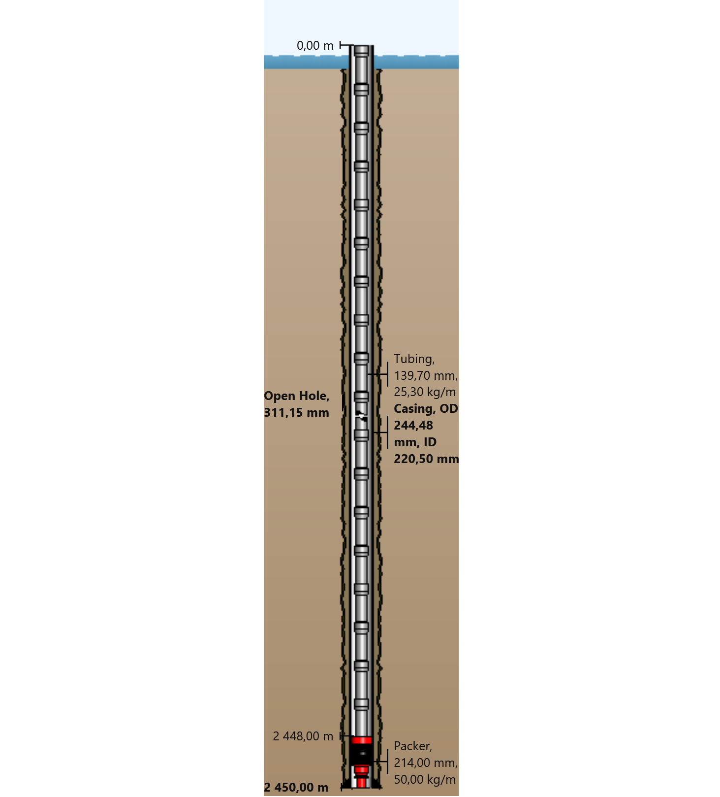

General Outputs Plots
  - Vertical Section
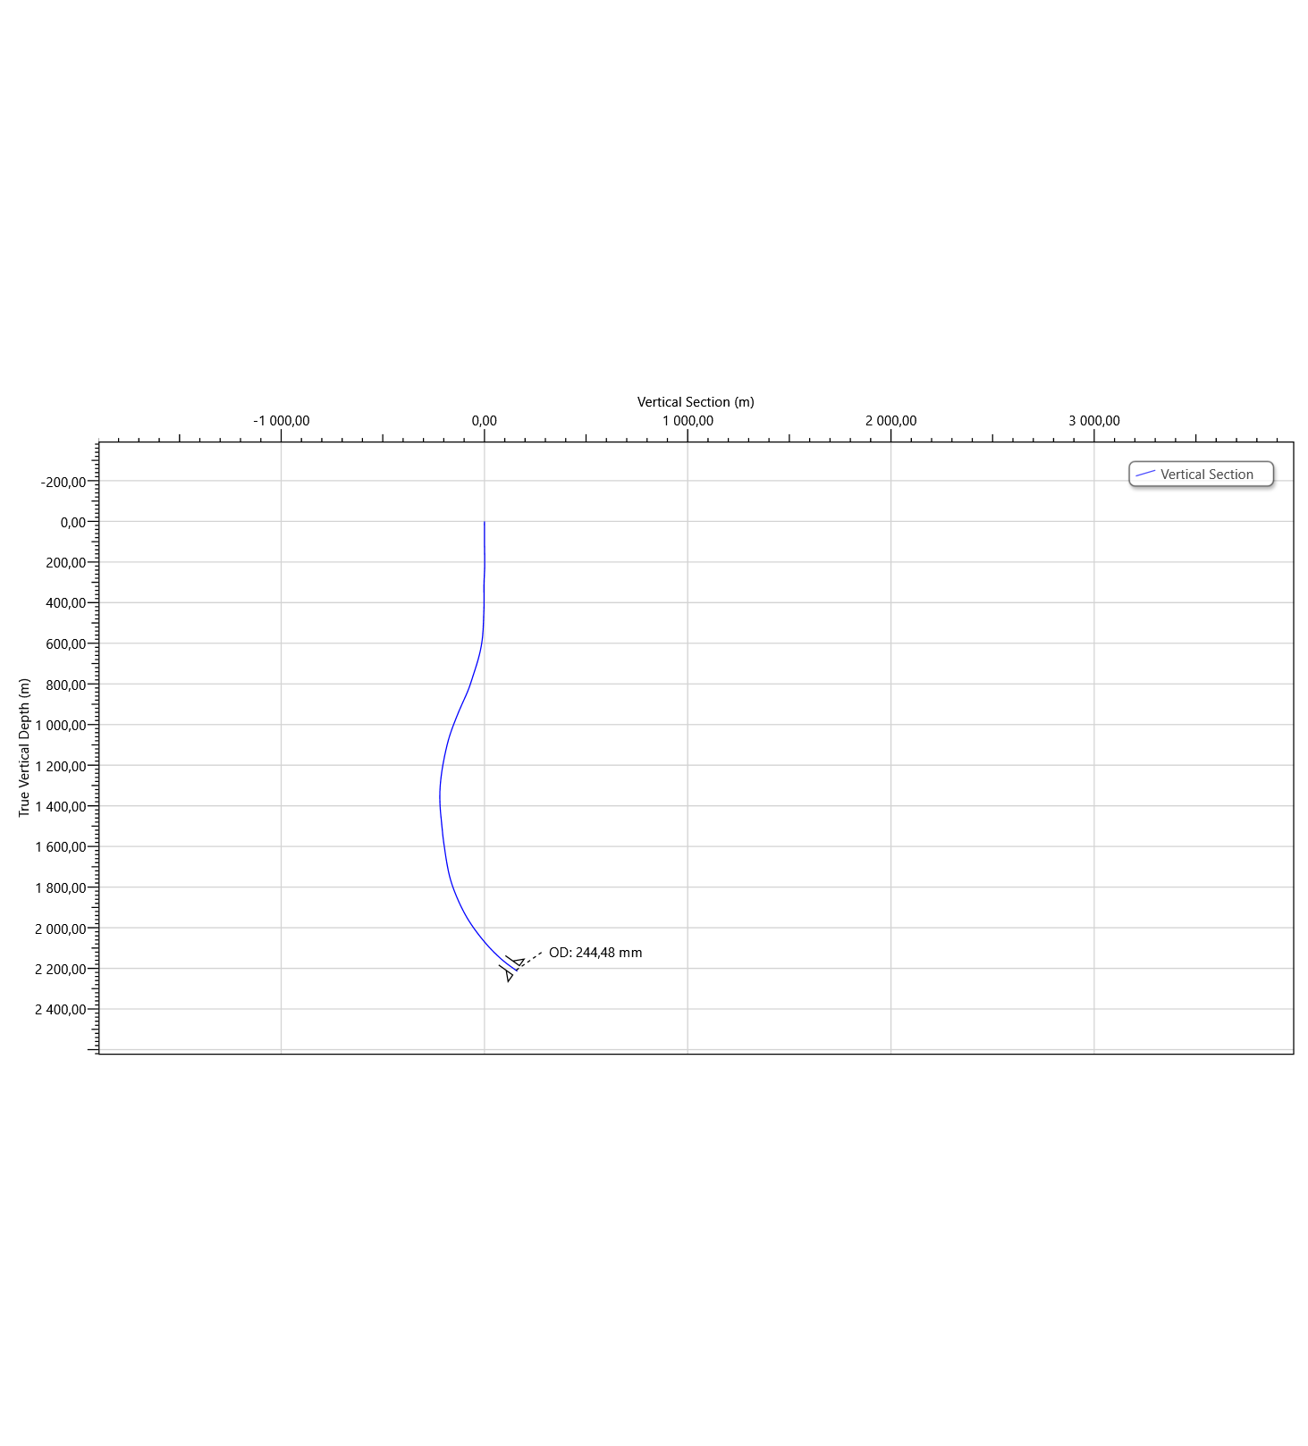
  - Plan View
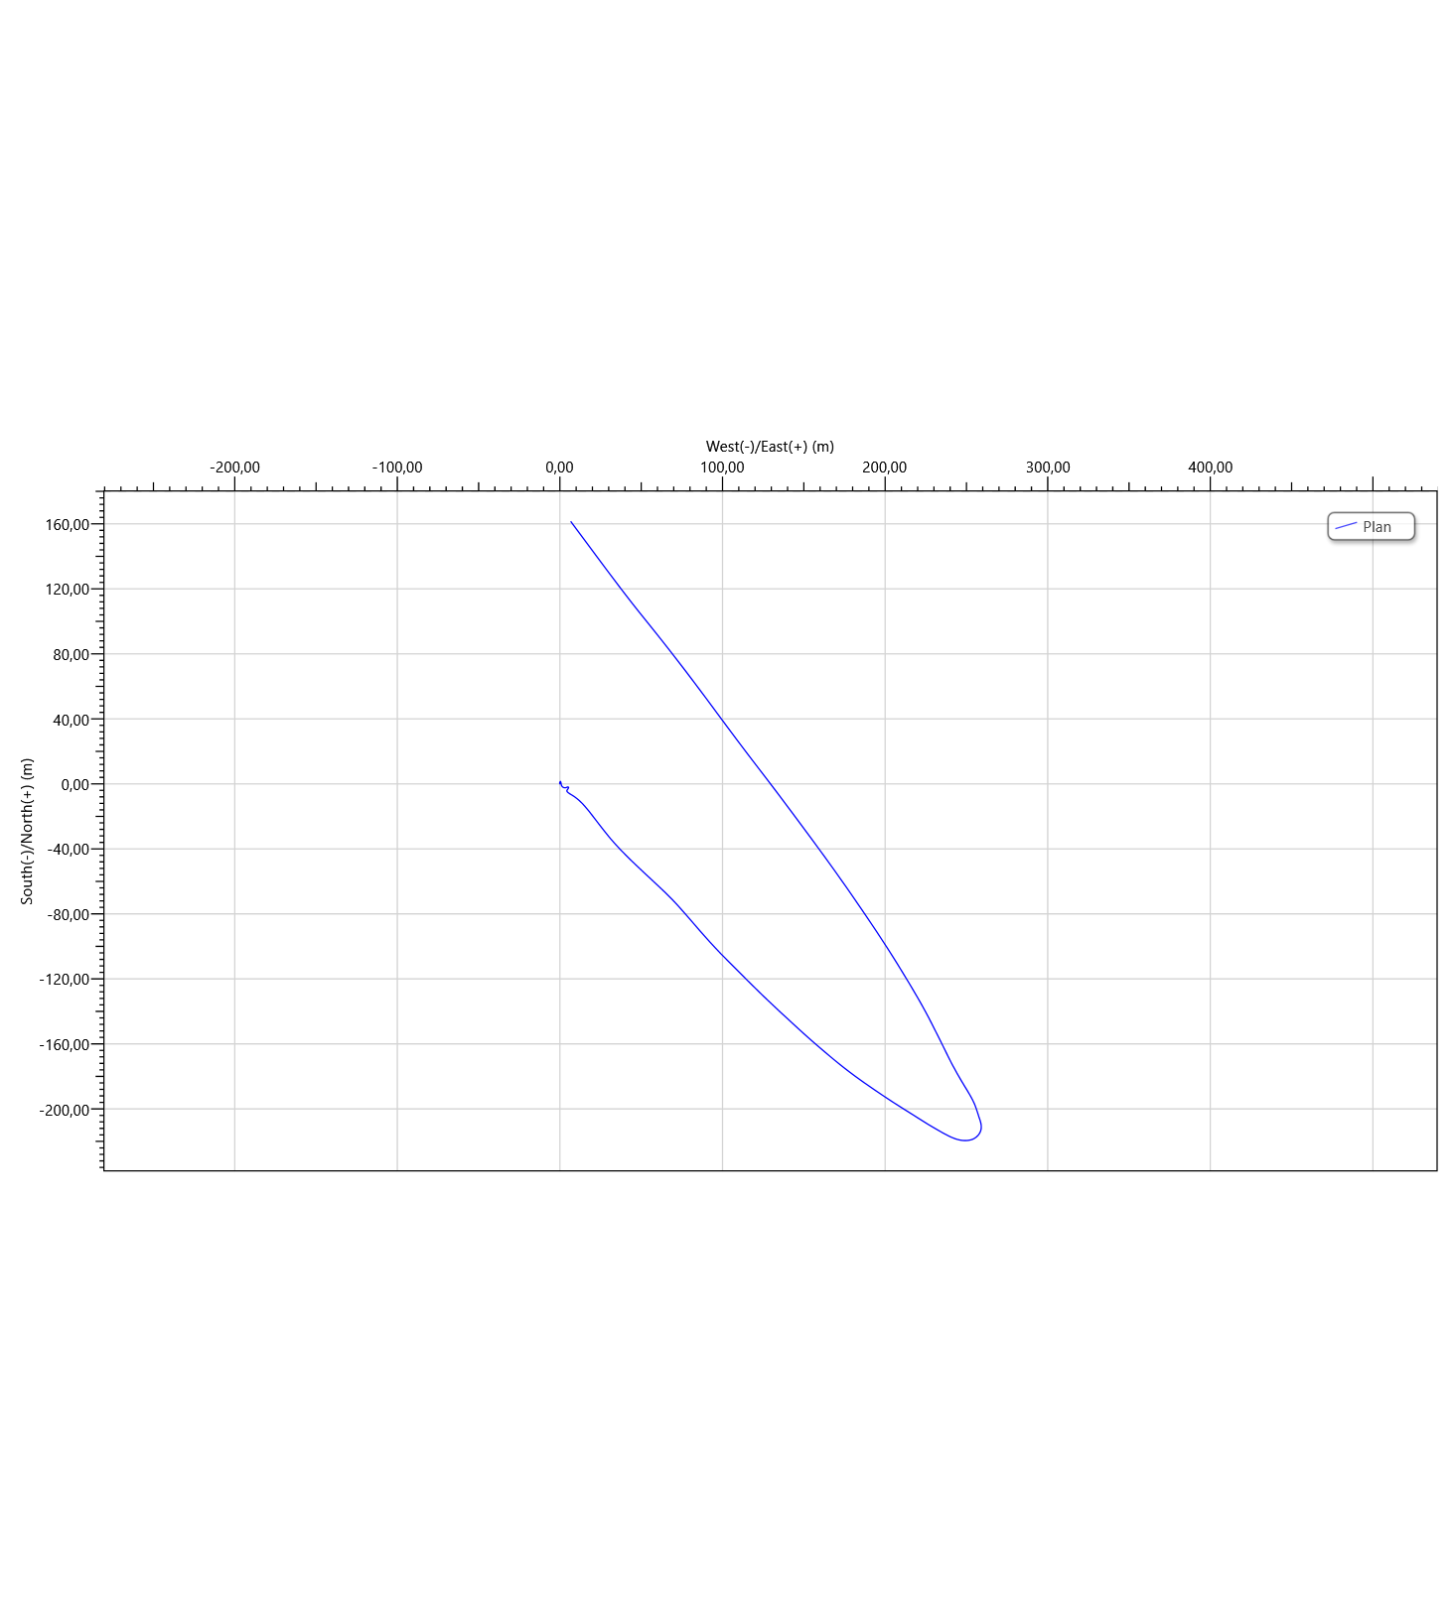

Torque & Drag Setup Data
  - Settings
Measured Depth of Bit | 2450,00 m | Bending Stress Magnification | No
Block Weight | 0,00 tonne | Stiff String Analysis | No
Enable Sheave Friction Correction | No | Viscous Torque and Drag | No
Pump Rate | 0,0000 m³/min | Contact Force Normalization Length | 9,45 m
Mechanical Efficiency (Single Sheave) | 97,00 | Lines Strung | 12
 |  | Side Force | N
Offset from Wellhead | m | Angle at Wellhead | °
  - Run Parameters
Start MD | 0,00 m | End MD | 2458,00 m
Step Size | 30,00 m
  - Normal Analysis Operational Parameters
Drilling | WOP/Overpull  (tonne) | Torque at Bit  (N-m)
Rotating On Bottom | NA | NA
Slide Drilling | NA | NA
Backreaming | NA | NA
Rotating Off Bottom
Tripping | Speed  (m/min) | RPM  (rpm)
Tripping In | 10,00 | 0
Tripping Out | 10,00 | 0
  - Friction Factors
Section Type | Coefficient of Friction
Casing | 0,23

  - String Fill Up
Use String Fill Up (Tripping In only) | No | Period | 0,00 m

Torque and Drag Results
  - Mechanical Limitations
Overpull Margin during a Tripping Out operation | 110,31 tonne | using | 100,00% of yield
Minimum Weight on Bit to Sinusoidal Buckle during a rotating on bottom operation | 17,42 tonne | at | 2448,00 m
Minimum Weight on Bit to Helical Buckle during a rotating on bottom operation | 24,63 tonne | at | 2448,00 m
Pick-Up Drag | 16,92 tonne
Slack-Off Drag | 11,52 tonne
Block Rating (Hoisting System) | tonne
Torque Rating (Rotating Equipment) | N-m
  - Load Summary
Load Condition | Stress Failure |  |  | Buckling Limits |  |  | Torque Failure | Torque at the Rotary Table  (N-m) | Total Windup with Bit Torque  (revs) | Total Windup without Bit Torque  (revs) | Measured Weight  (tonne) | Total Stretch  (m) | Axial Stress = 0 |  | Neutral Point Distance from surface  (m) | Neutral Point Distance from Bit  (m)
 | Fatigue | 90% Yield | 100% Yield | Sinusoidal | Helical | Lockup |  |  |  |  |  |  | Distance from Surface  (m) | Distance from Bit  (m)
Tripping In |  |  |  |  |  |  |  | 0,0 | 0,0 | 0,0 | 38,62 | 1,44 | 2022,22 | 427,78 | 2450,00 | 0,00
Tripping Out |  |  |  |  |  |  |  | 0,0 | 0,0 | 0,0 | 67,06 | 1,85 | 2145,03 | 304,97 | 2450,00 | 0,00

Torque and Drag Plots
  - Effective Tension
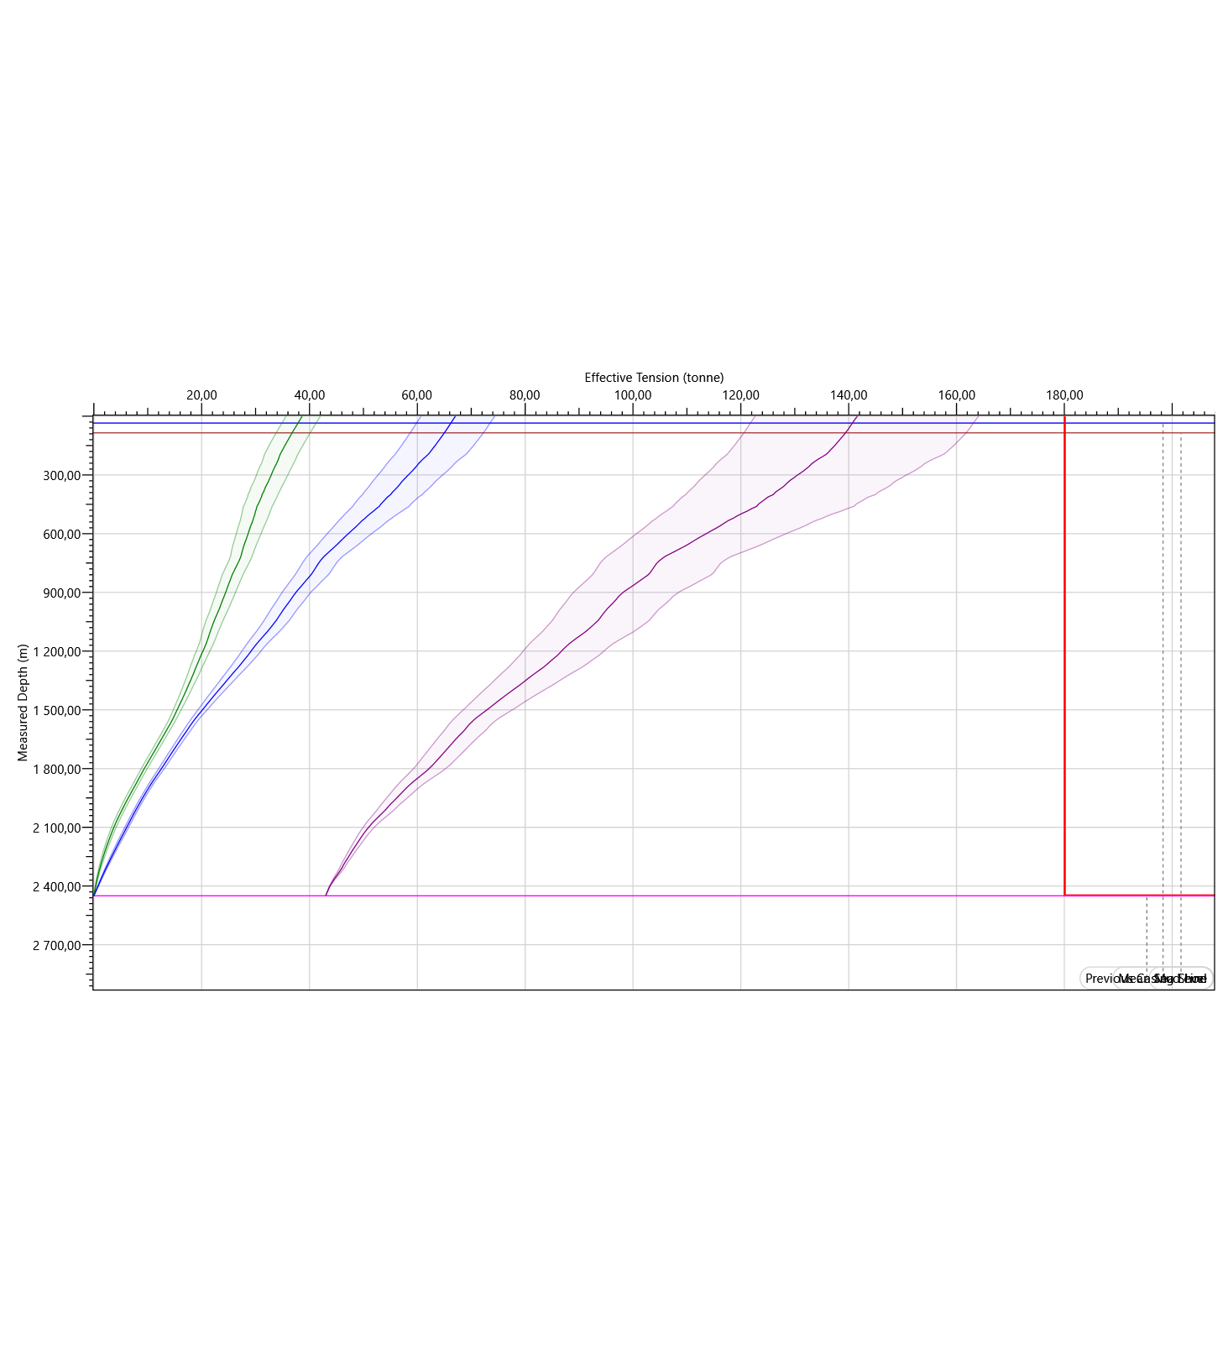

  - Hook Load
